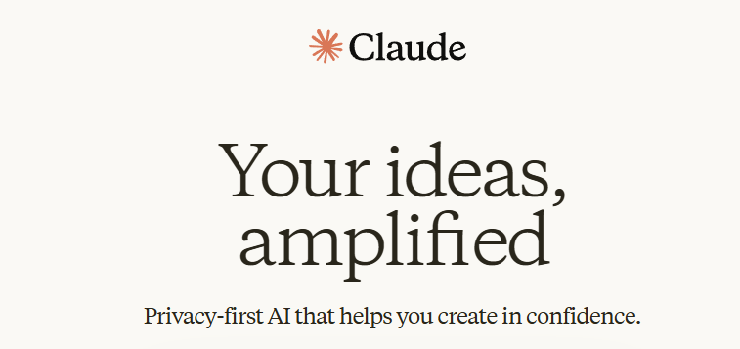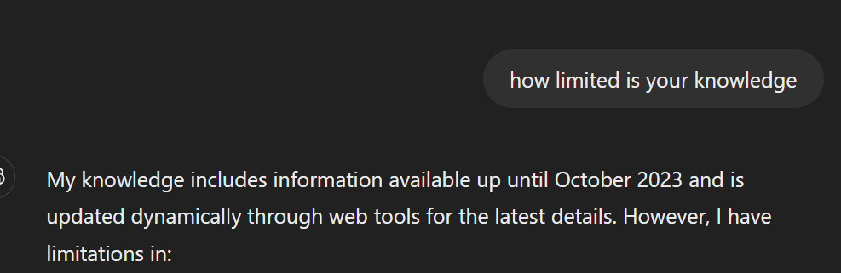

Chathpt has its specilaity to give you a perfect prompt on the basis of your demand such way you make a best prompt

1. Act as a expert writter
2. Write book with those basic idea
3. Details.. start end
4. Write a book like wording of rich dad poor dad.
5. Make a special formats
6. Make them a actor on every prompt that you write.
7. Include all basic details in prompt
8. All details
9. Make use of examples everytime
10. Use proper word, only text what you want in clear way

Basic way to write a prompt

This is alternative tool of the chatgpt.

Simple and effective

2

1